Analysis of Historical Airplane Crashes

* We started off asking if crash location has anything to do with the actual crash cause?

We found that when we grouped by location and number of crashes that it seems that based on this chart that areas that are more prone to inclement weather such as snow or wind seem to have more crashes. This led us to believe that weather might be a factor in causing airplane crashes.

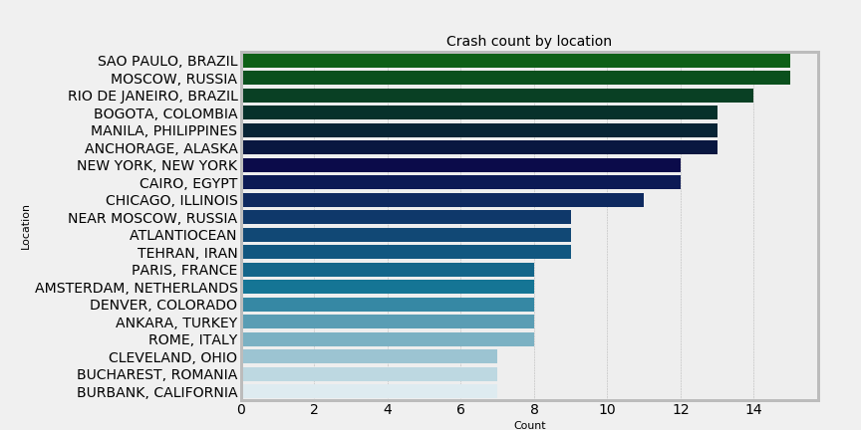

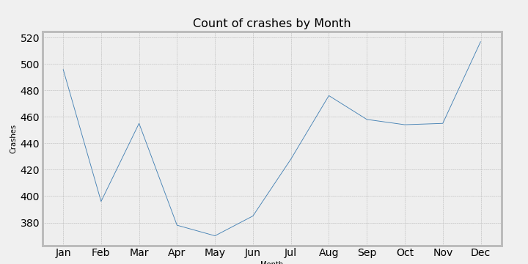

* Is there a correlation between the highest number of operator crashes and operator fatalities?

We found that only three of the top operators with the highest number of crashes are military. Among the operators with the most fatalities, the majority have a fairly good survival rate.

Side note: Aeroflot is one of the oldest Airlines in the world, starting in 1923. During the Soviet Era, Aeroflot was the Soviet national airline and the largest airline the world. This airline was used for military and commercial flights.

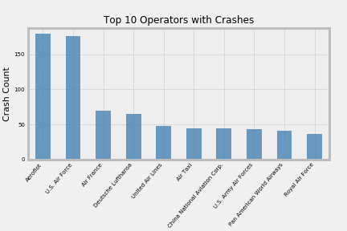

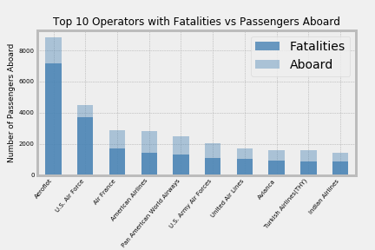

* Do Military and Commercial Crashes follow the same pattern overtime?

We found that military crashes spiked in the early1940’s, due to World War II. While commercial crashes spiked later in the 1940’s and early 1950’s. There was an uptick in commercial flights at that time and this was known as the “Golden Age of Flight”.

